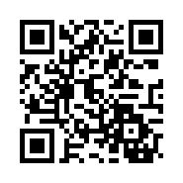
2. Halbjahr 2023
English Grammar Refresher for You
231-40660, Do, 17.00 – 18.00 Uhr, BildungsCampus Neuenhof, Raum B.0.01

2nd Unit, Thursday, 29 February 2024

Homework

Use the correct form of the past simple, past perfect or present perfect:
- I (to read) the report yesterday.
- You (to read) the news today?
- I (to be) married for 20 years now.
- We (not to be able) to eat at the restaurant because we (not book) in advance.
- I (never, to eat) so much cake.
- I thought they already (to have) dinner when we arrived yesterday.

Complete each sentence with the appropriate form of the future 1 or future 2 tense:
- I (to be) at home tonight.
- I (to go) to our CEO’s presentation.
- By the end of the month they (to save) enough money for the trip.
- Do you think the data (to convince) our boss?
- Next year, she (to learn) French for five years.
- I hope we (to meet) our deadlines this month.
- By the time you come back I (to read) the book.
- My flight (to leave) at 8.30 shar.

